**Heading:** Sprint 2 plan, MemLoc, Remind by Location, sprint completion date: 02.08, rev 1, 01/26/2022

Goal: Build out location integration with frontend and backend (early building phase)

**Task listing**

User story 1 : As a user I want to be able to provide my location and see visual feedback (13 points)

1. Build js web router (4h)
2. Build interface between iOS location app and js backend (4h)
3. Provide API for frontend to use (4h)
4. Integrate FE and BE functionality (3h)

User story 2: As a user I want to be able to get input reminders at a specific location and times so that I can later on be conveniently be reminded at the place and time. (8 points)

1. Adding a location input that will give coordinates that can later be sent to the backend (through an API)(4h)
2. Get coordinates from the location that can be sent to the backend (1h)
3. Adding a calendar date that can compare to the current date (through API)(4h)
4. Get the time stamp that can be compared to current time(1h)

**Team roles:**

Alexandra: Frontend

Mythili: Scrum Master, Backend

Abirami: Frontend

Surya Rani: Backend

Case Delst: Product Owner, Backend, Frontend

Initial task assignment: A listing of each team member, with their first user story and task

assignment. This should look like:

Alexandra: User Story 2: 1, 2

Mythili: User story 1, 1, 4

Abirami:User story 2: 3,4

Surya Rani: User Story 1: 3,4

Case Delst: User story 1: 2, 4

Initial burnup chart: A graph giving the initial burnup chart for this sprint and is labeled as such

with sprint number and project name and is located in the lab.

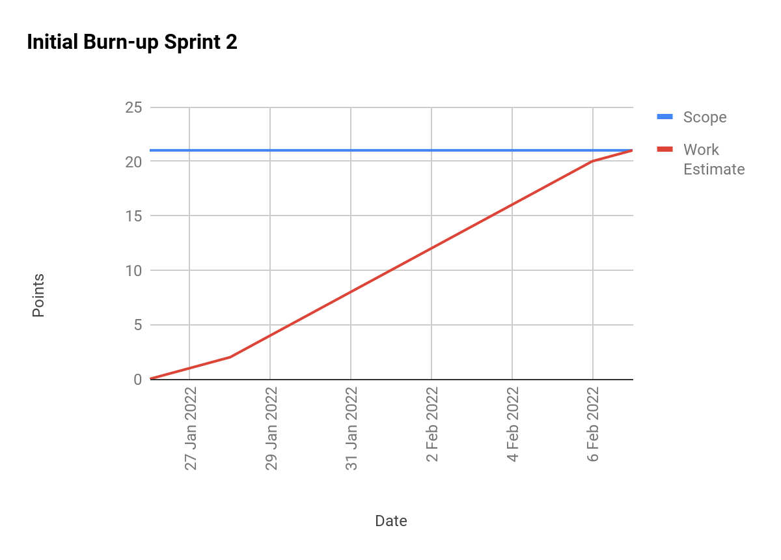

scrum board:

<https://trello.com/b/dp54eGNN/memloc-s2>

Scrum times:

Monday/Wednesday/Friday @ 3pm

Meeting with TA Tuesday @ 3 pm